DEVOPS COURSE

KODECLOUD USERNAME AN PASSWORD
username : Vishnupriya
email : v.priyathiru@gmail.com
password : VishnuPriya@09*

1. Development Environment
2. Commit to Git
3. Build Environment
4. Test Environment for test.
5. Deploy to Production.

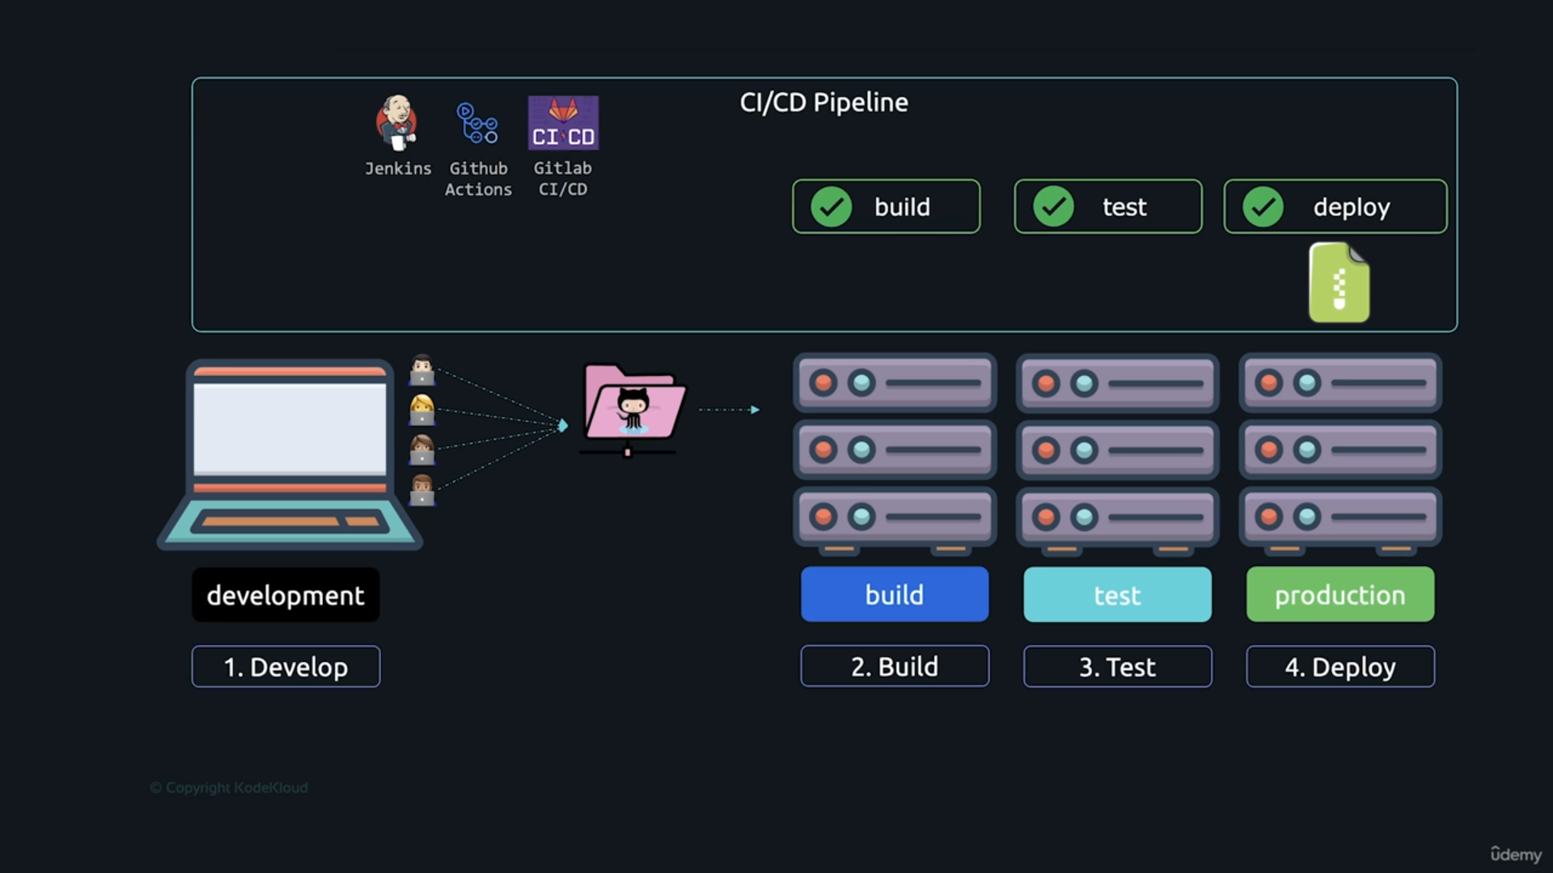

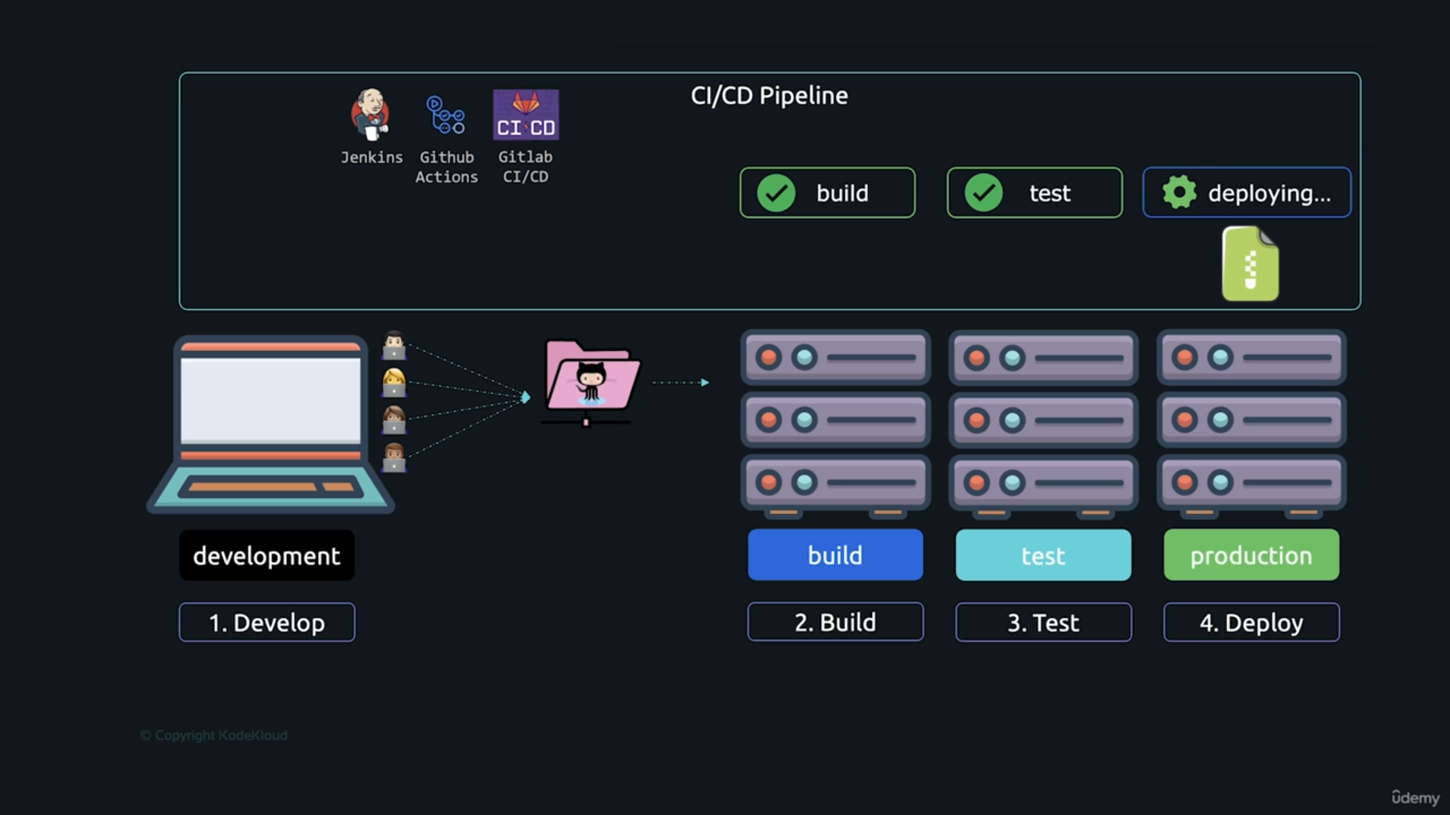
All Environments should be installed necessary software languages to be installed before build and test and deploy

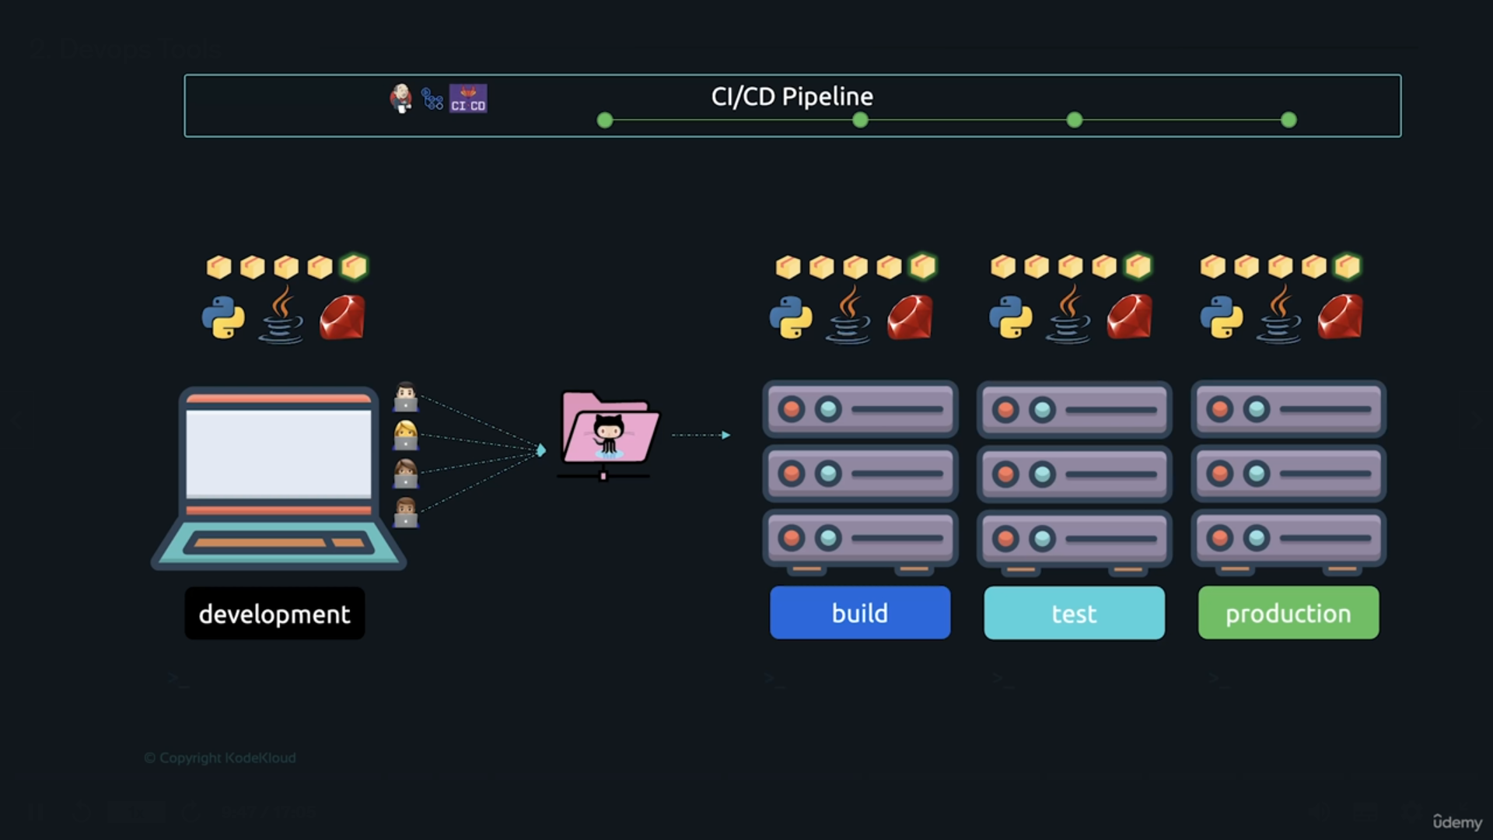

At the time of taking build need to create Docker image

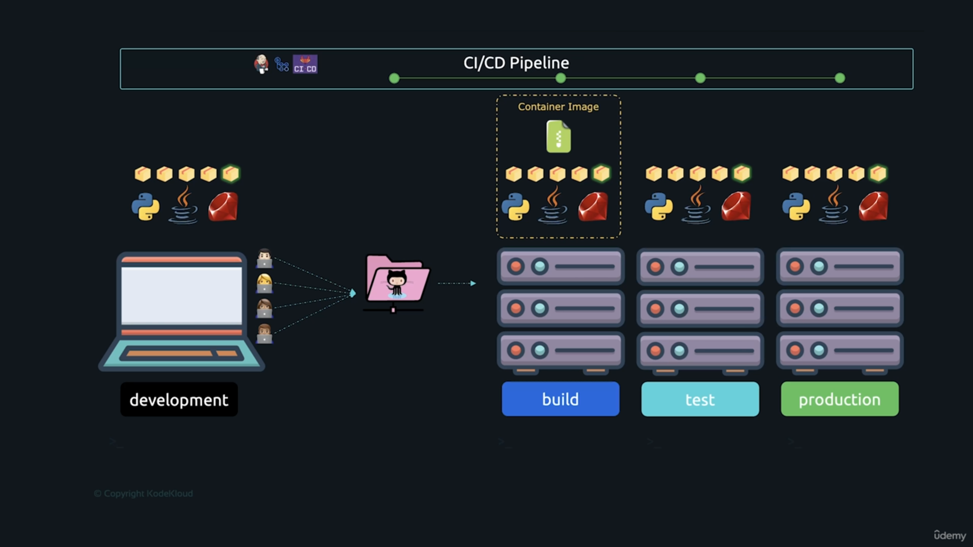
At the time of create and run the Docker image it will create a container. The same container to be created in all environments.

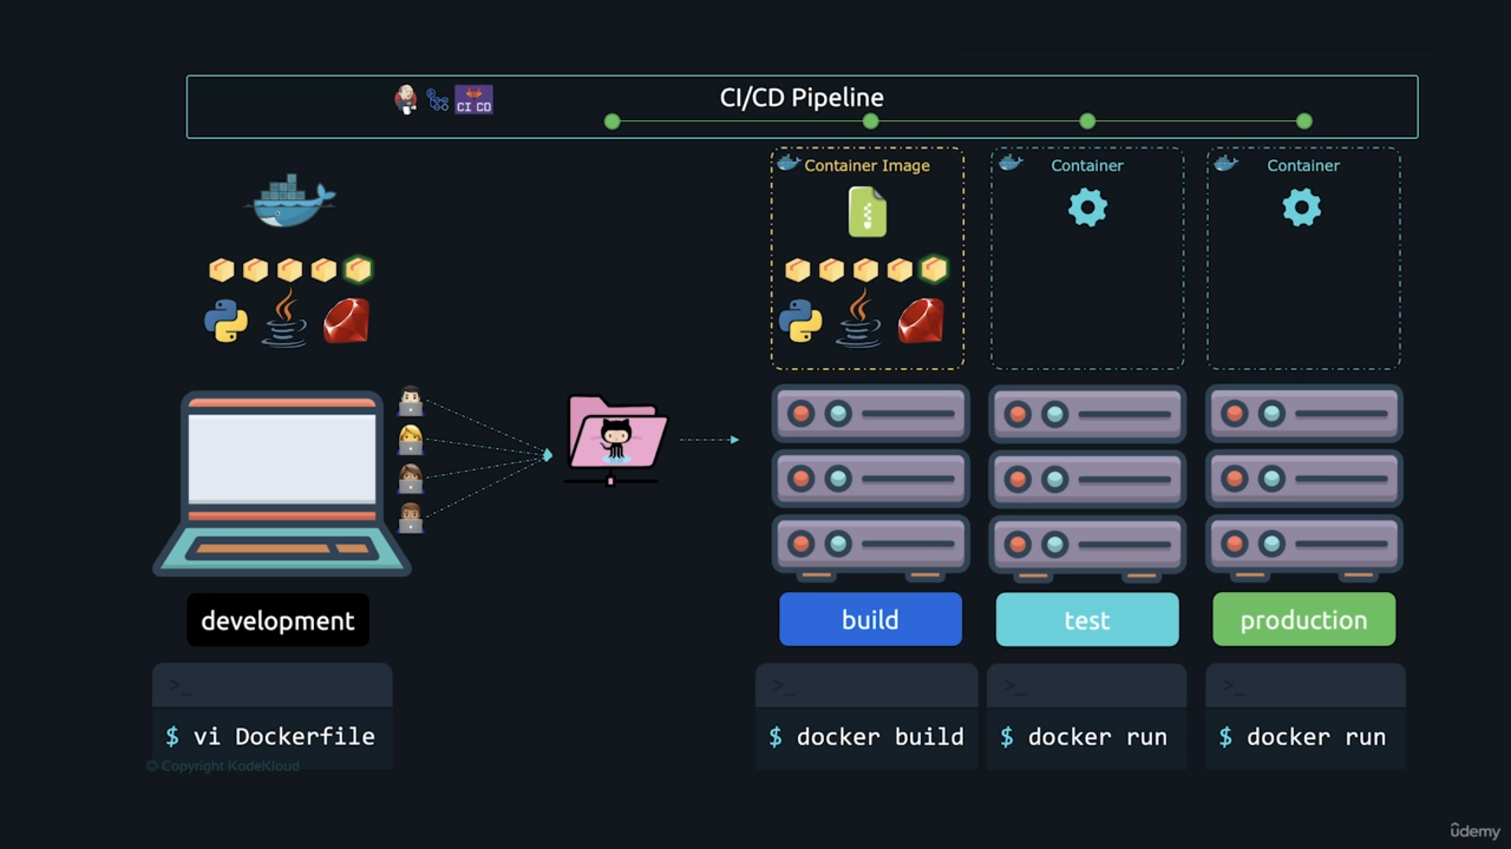

Once Deployed into the production it will be available to all instances by using templates.

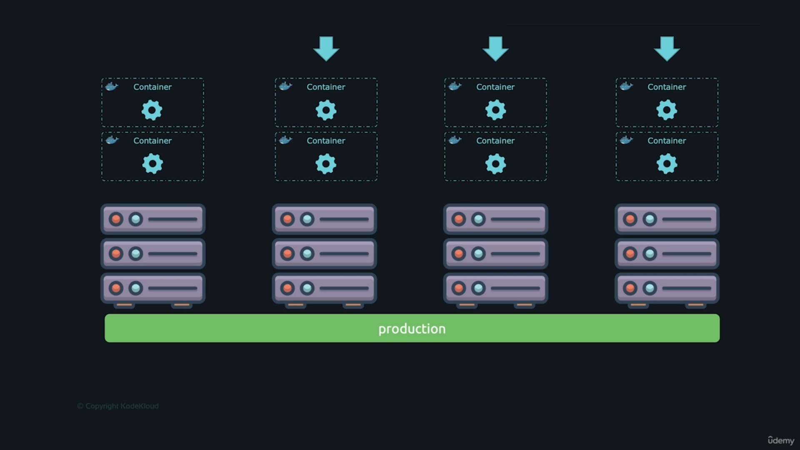
The deployed containers will be stored in main (root) Container with the configuration file main.tf (Infrastructure as Coe (IAC) Then it will be reconfigured in all instances with the help of TERRAFORM tool

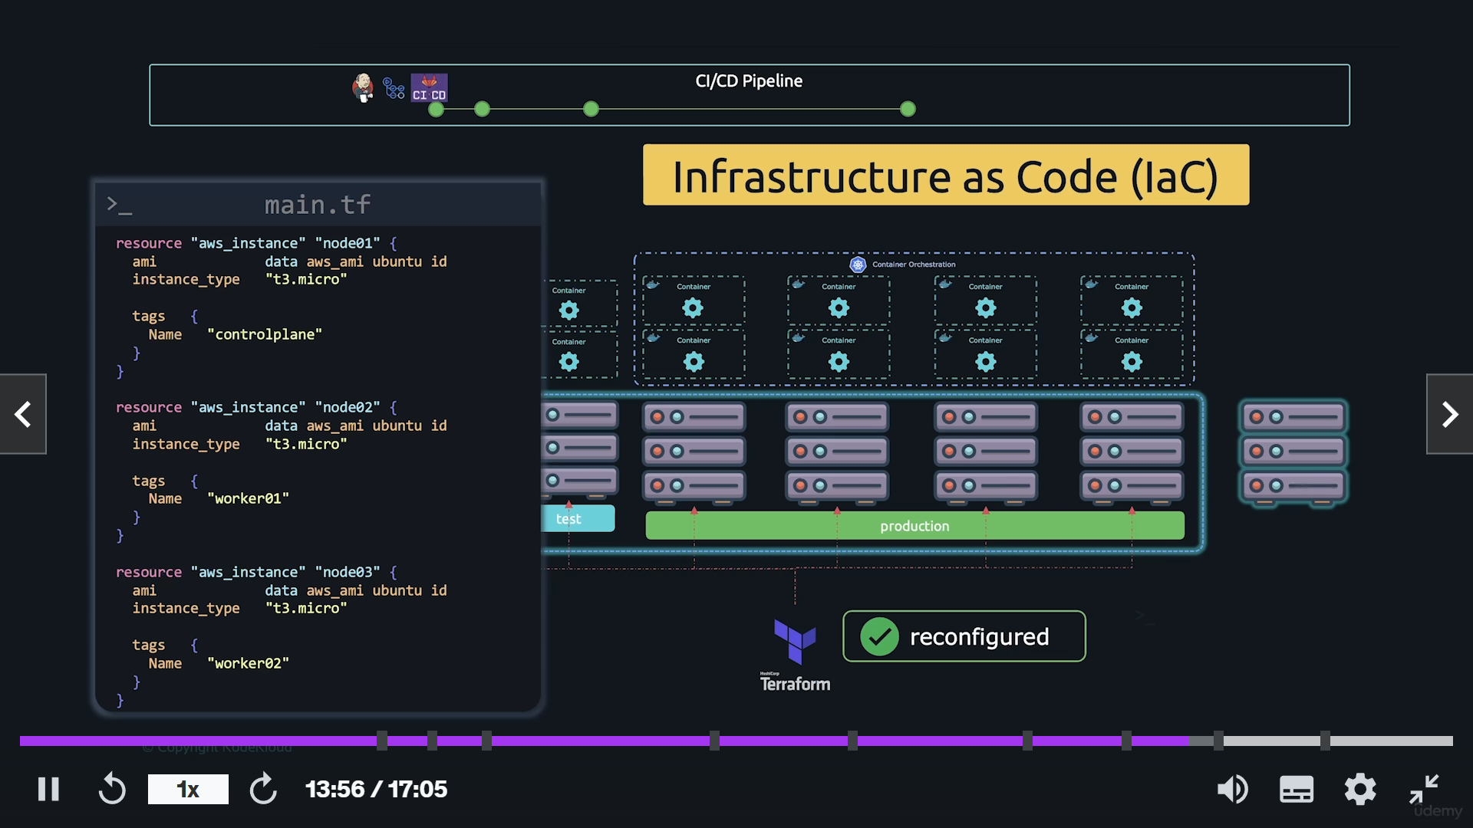

Then the playbook.yaml file will be deployed all the containers to its instances into kubernes clusters.

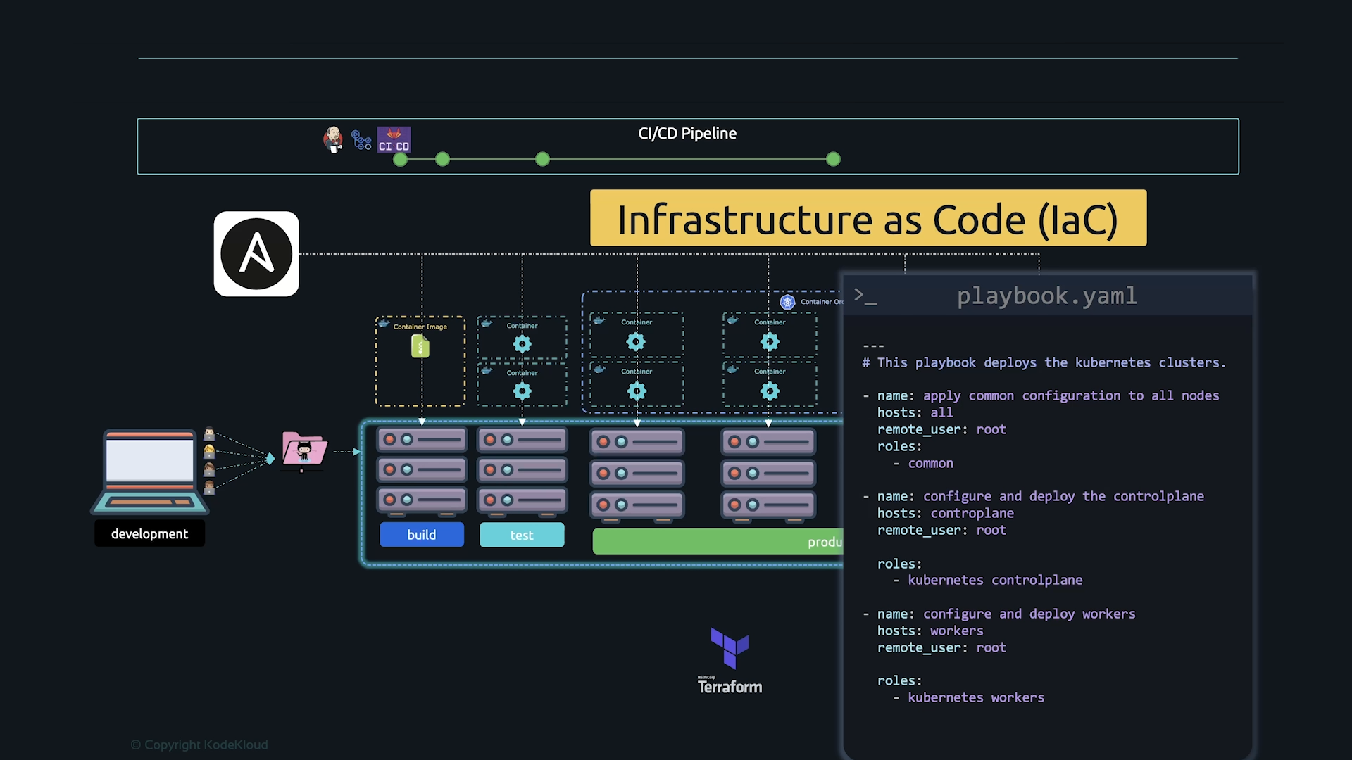
Configuration process is automated by Ancible tool is used to proposed configuration on clusters. If there is any change made it will be automatically configured in to all clusters. This code also stored in repository GITHUB.
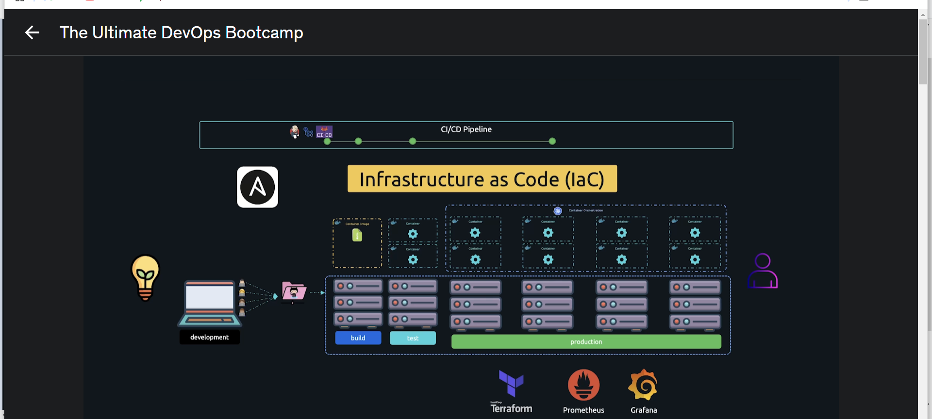
Prometheus collects information of metrix from different server and stores it centrally and able to monitoring and visualizing the health checks of servers with the help of Grafana.

Why LINUX

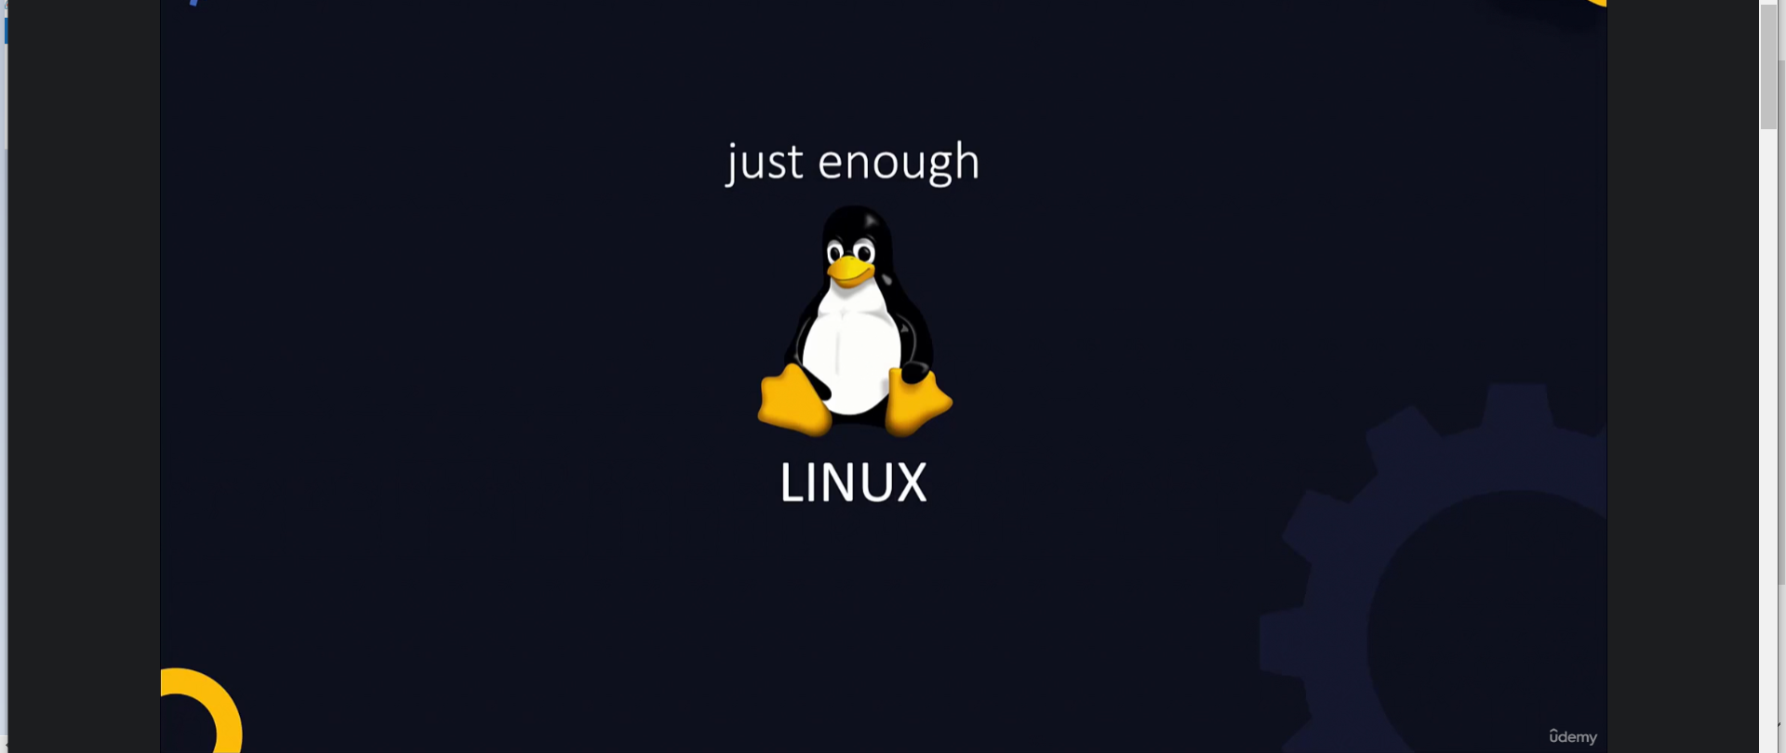
Most of the devops tools base developed in linux.

Shell Types
1. Bourne Shell (Sh shell)
2. C Shell (csh / lcsh)
3. Zshell (zsh)
4. Bourne again Shell (bash)

Bash Shell

Shell Commands
echo $Shell - echo command is used to print $Shell Environment variable.
/bin

Basic Linux Commands

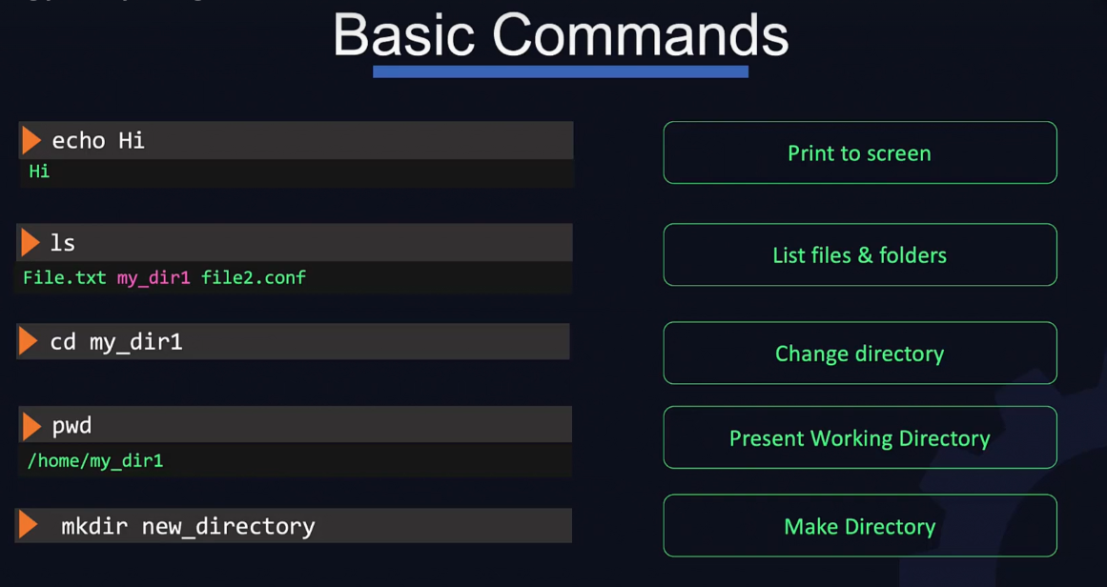
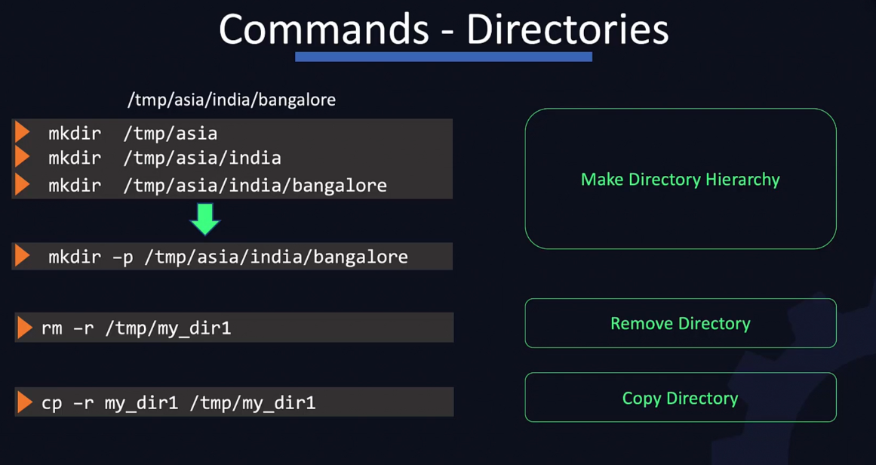

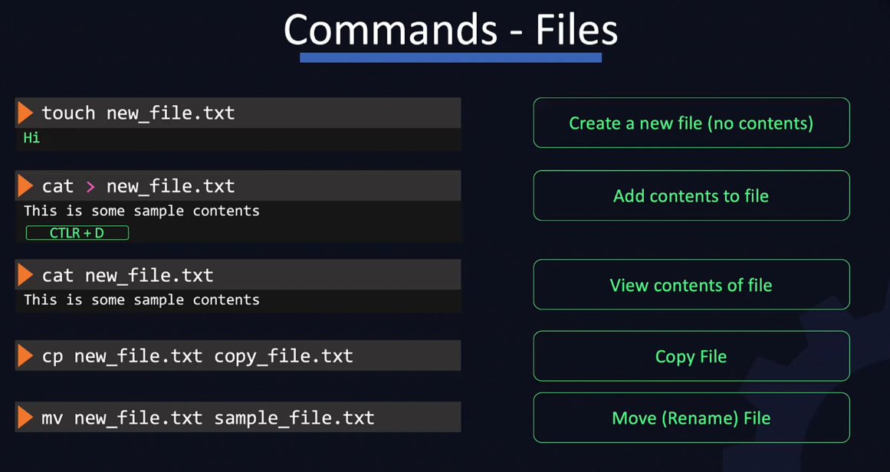

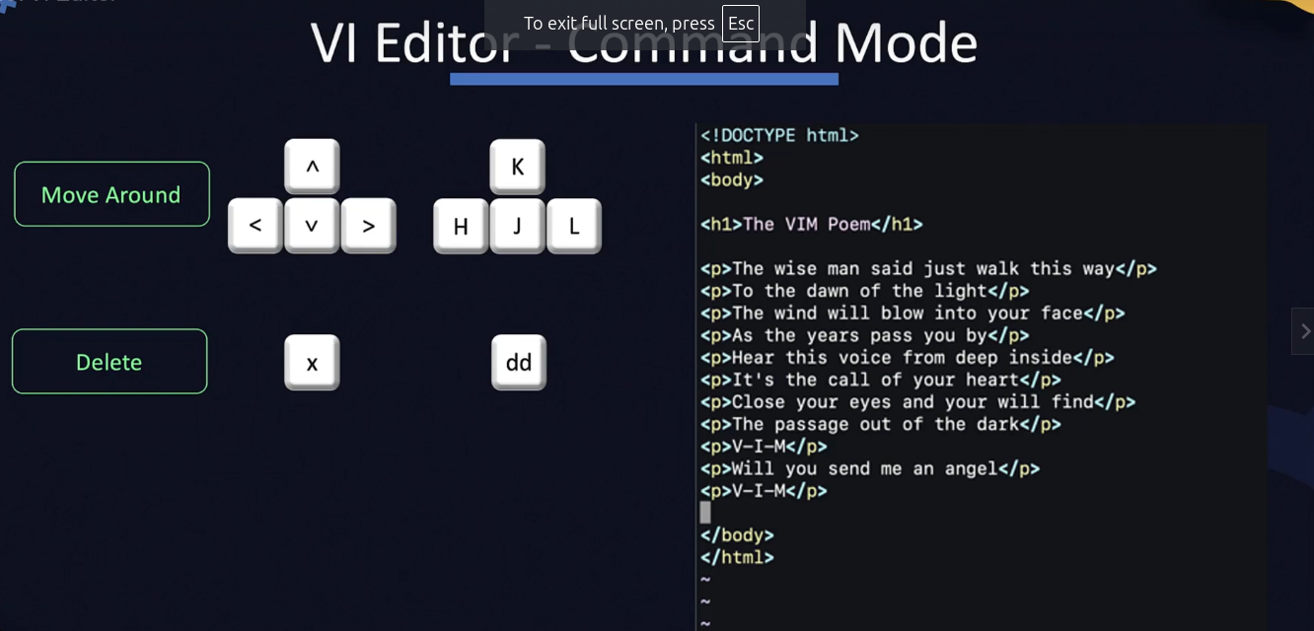
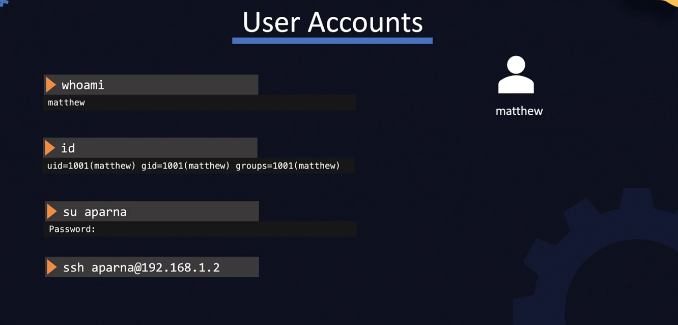
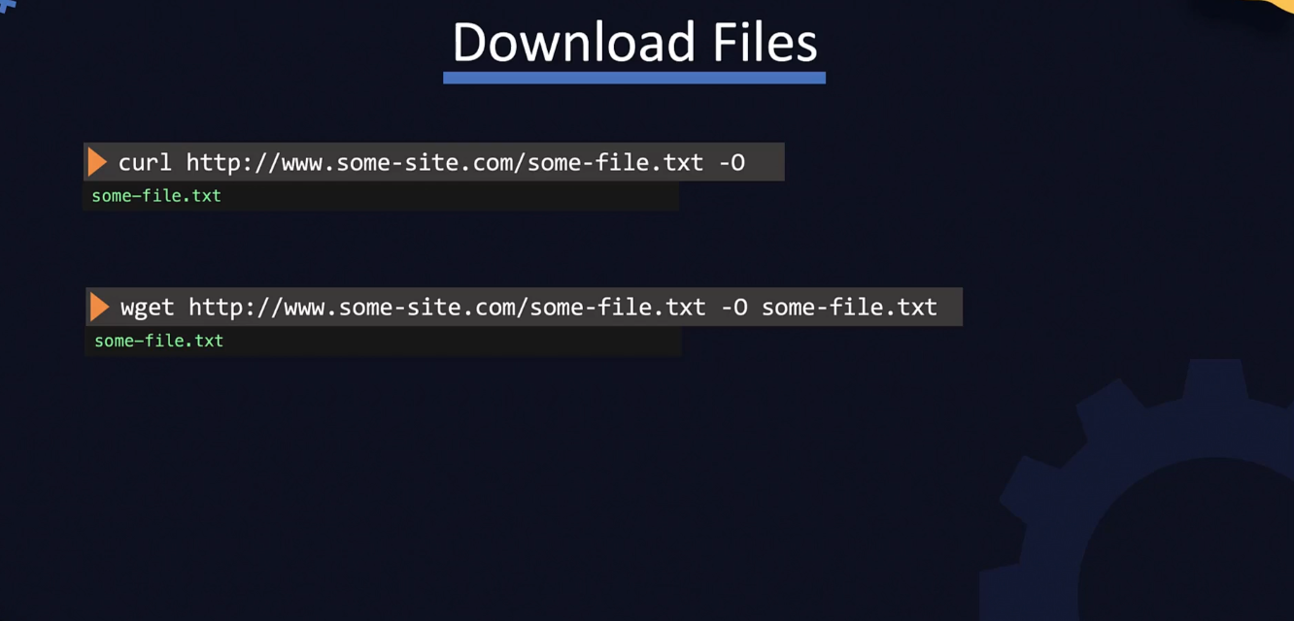
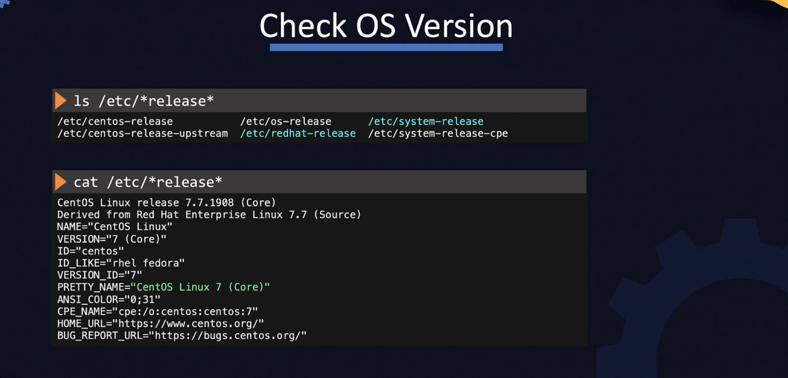
PACKAGE MANAGER

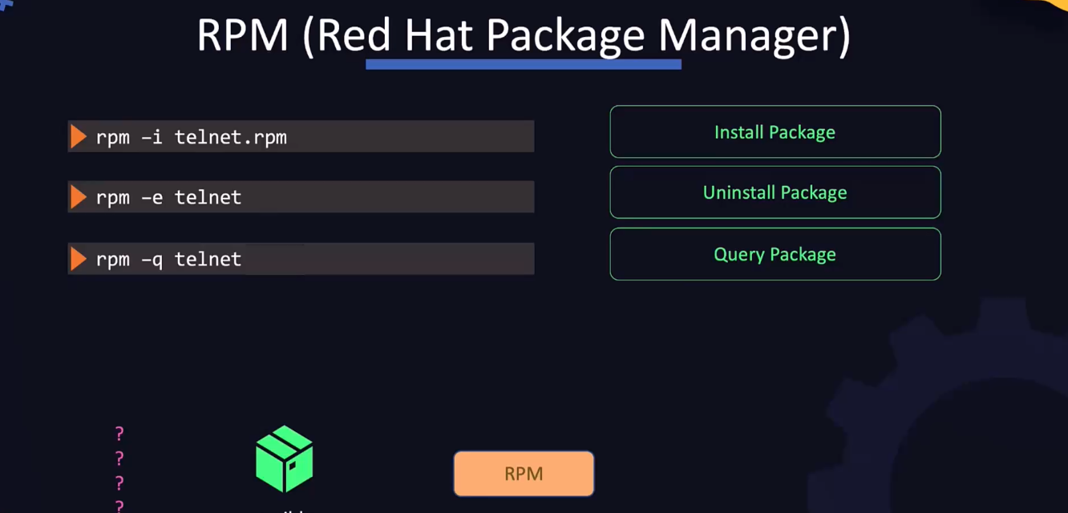
INSTALL ANSIBLE INTO YOUR SYSTEM
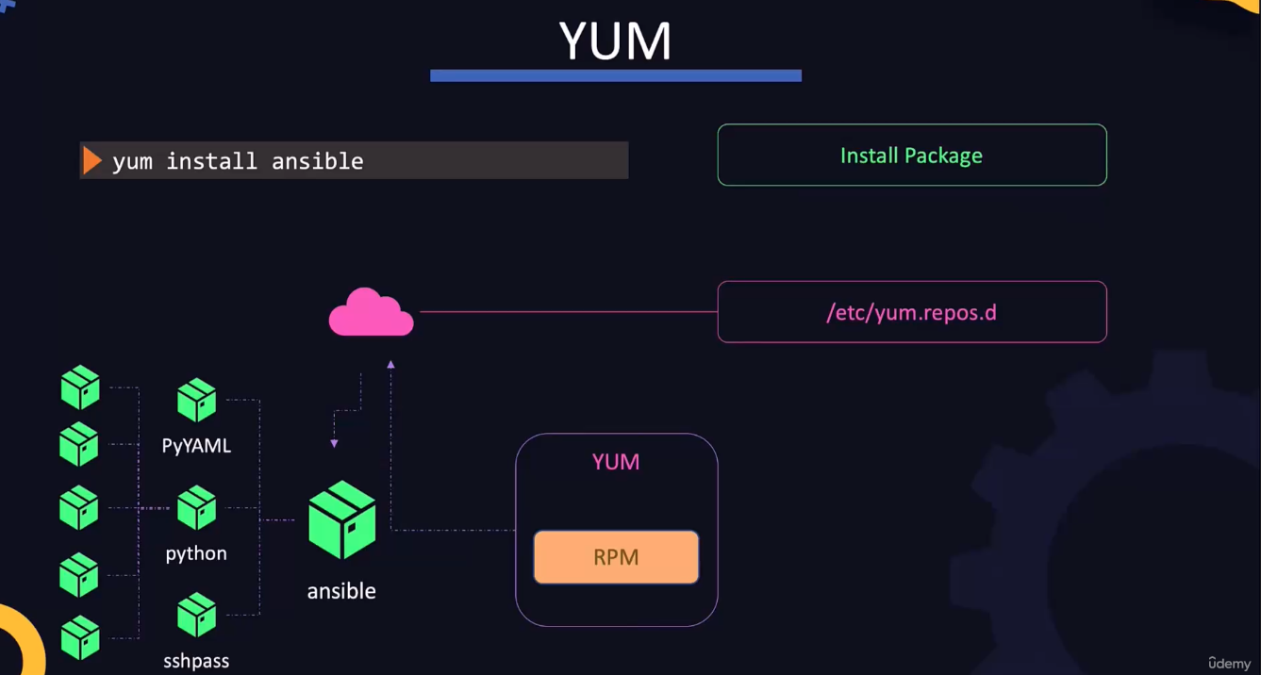

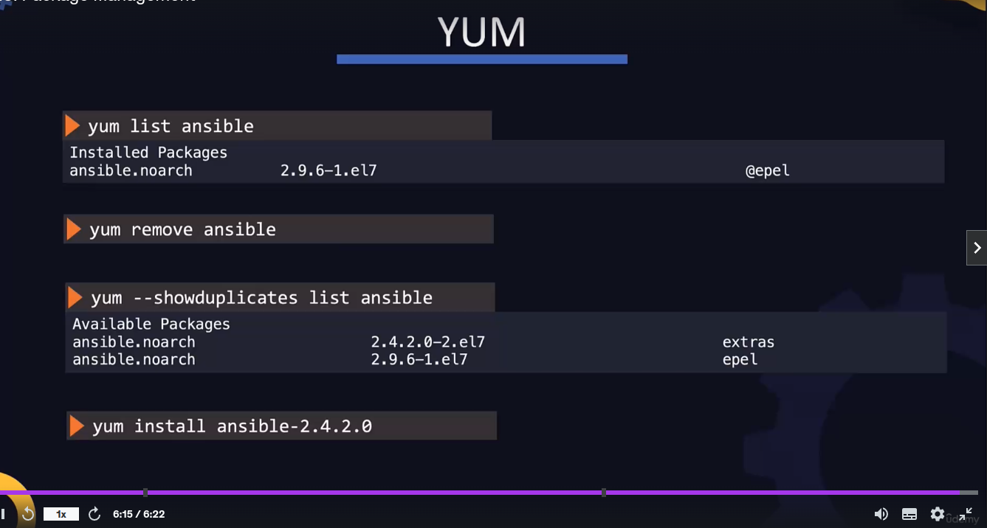
FIND THE PACKAGES FROM REPOSITORY
AND INSTALL THE SPECIFIC PACKAGE USING yum

SERVICES COMMAND TO START / STOP/ STATUS OF SERVICE

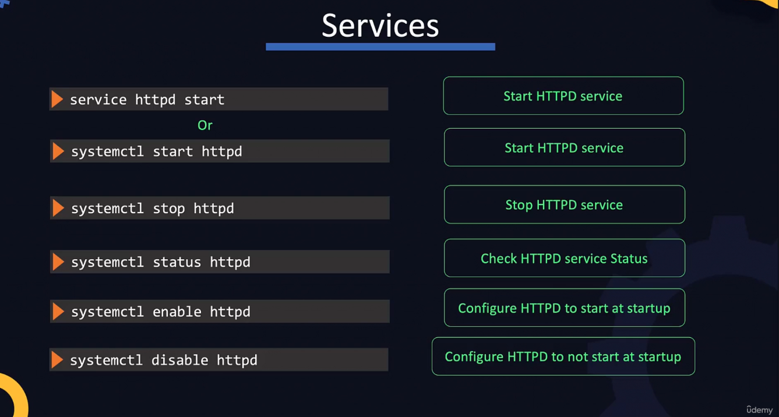

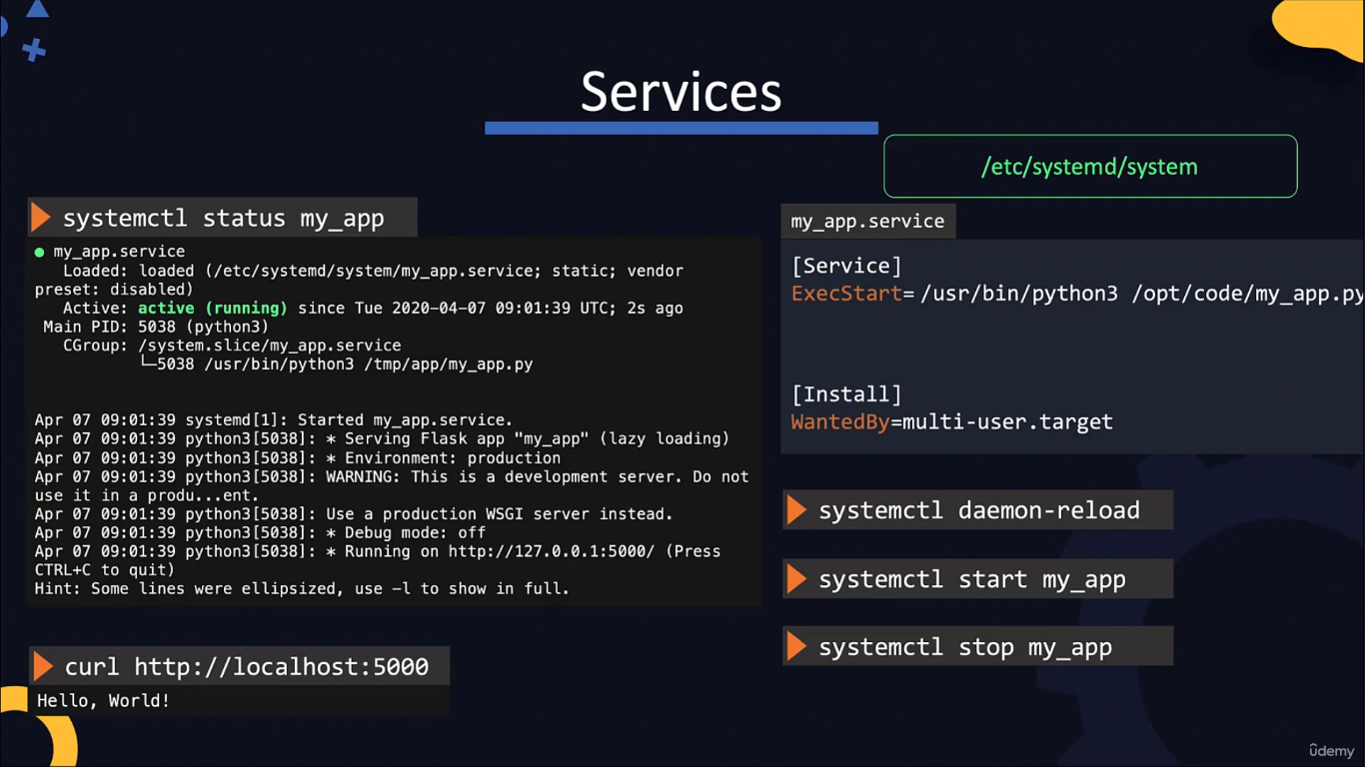

Service command for app
NETWORK
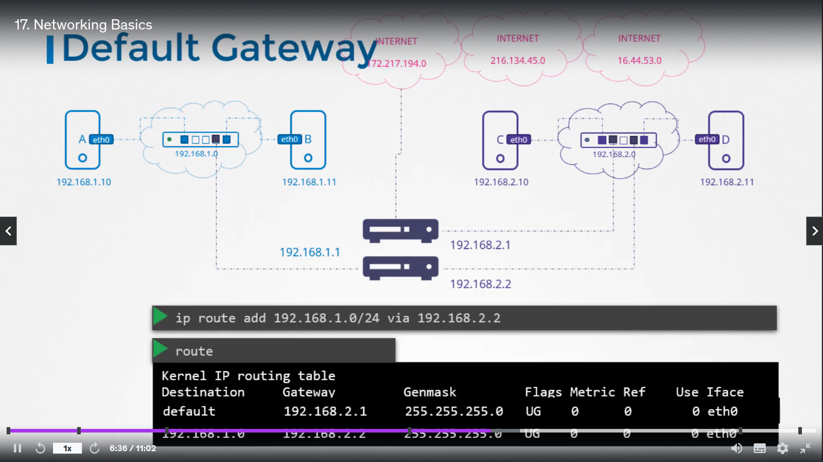
DNS – DATA NAME SERVER

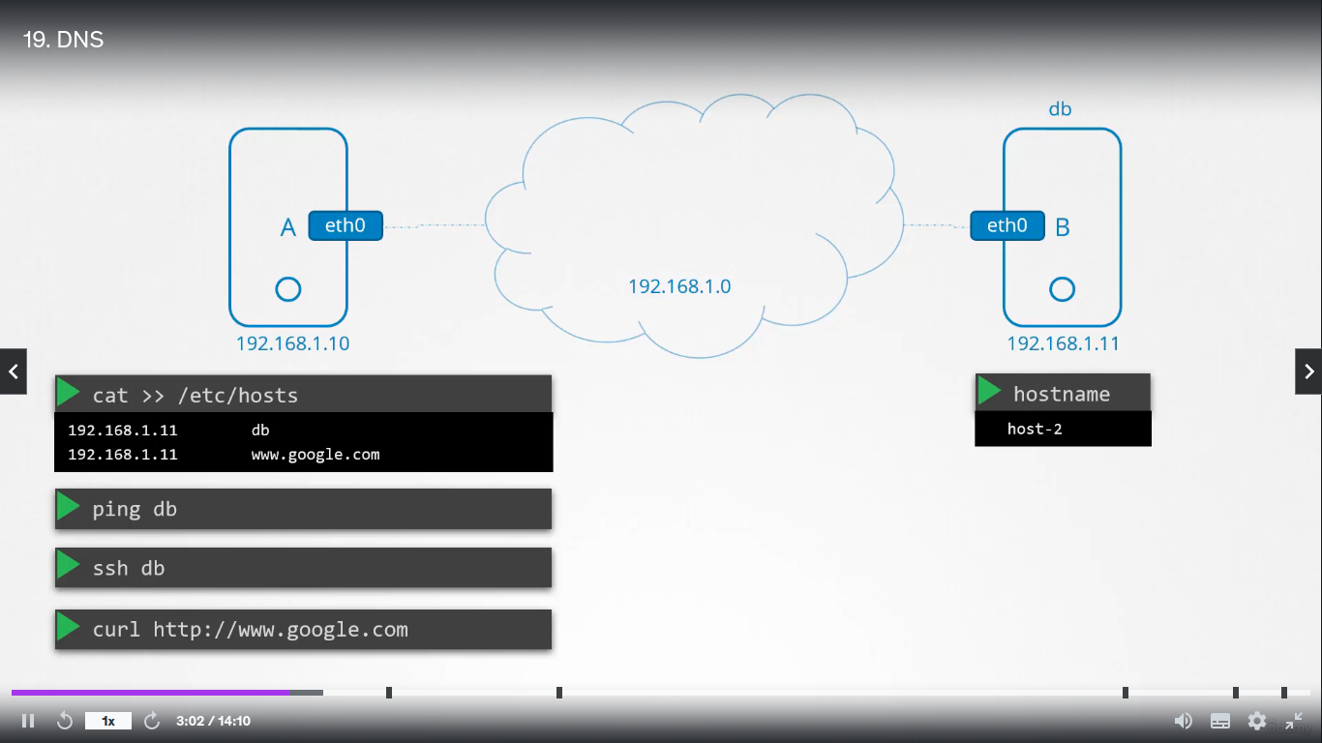

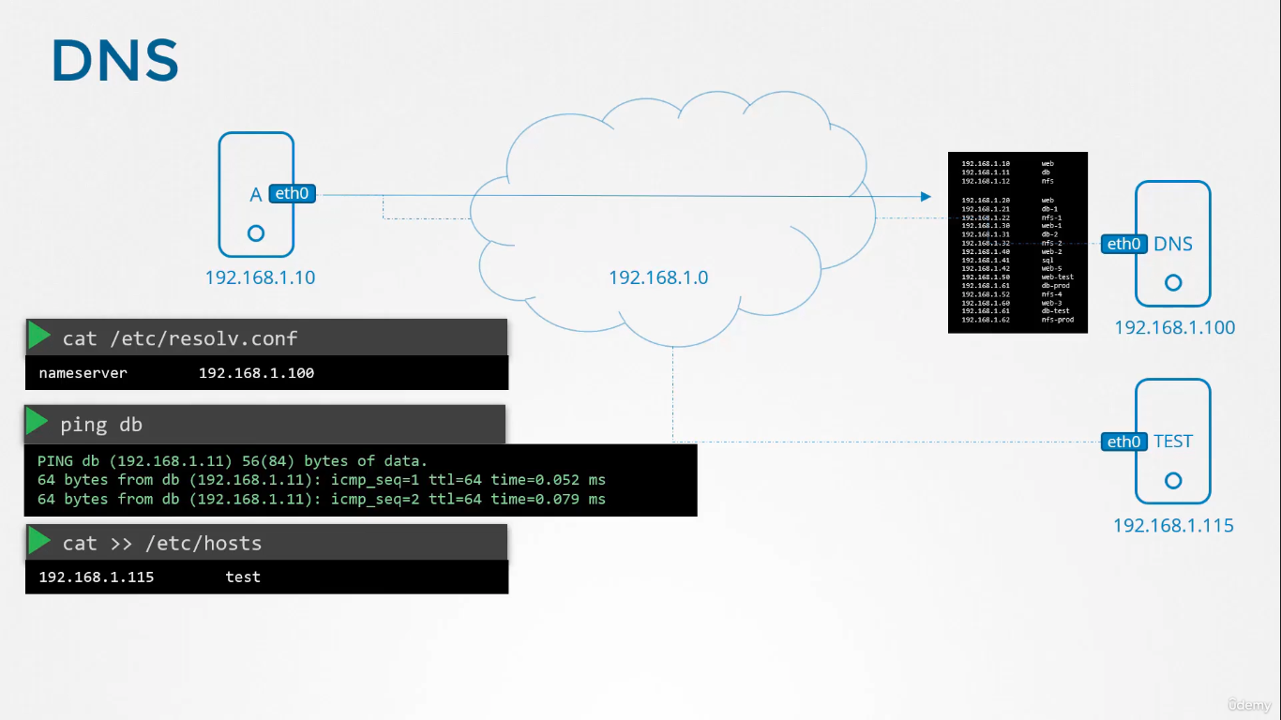
POITING THE HOST SERVER AND FILES
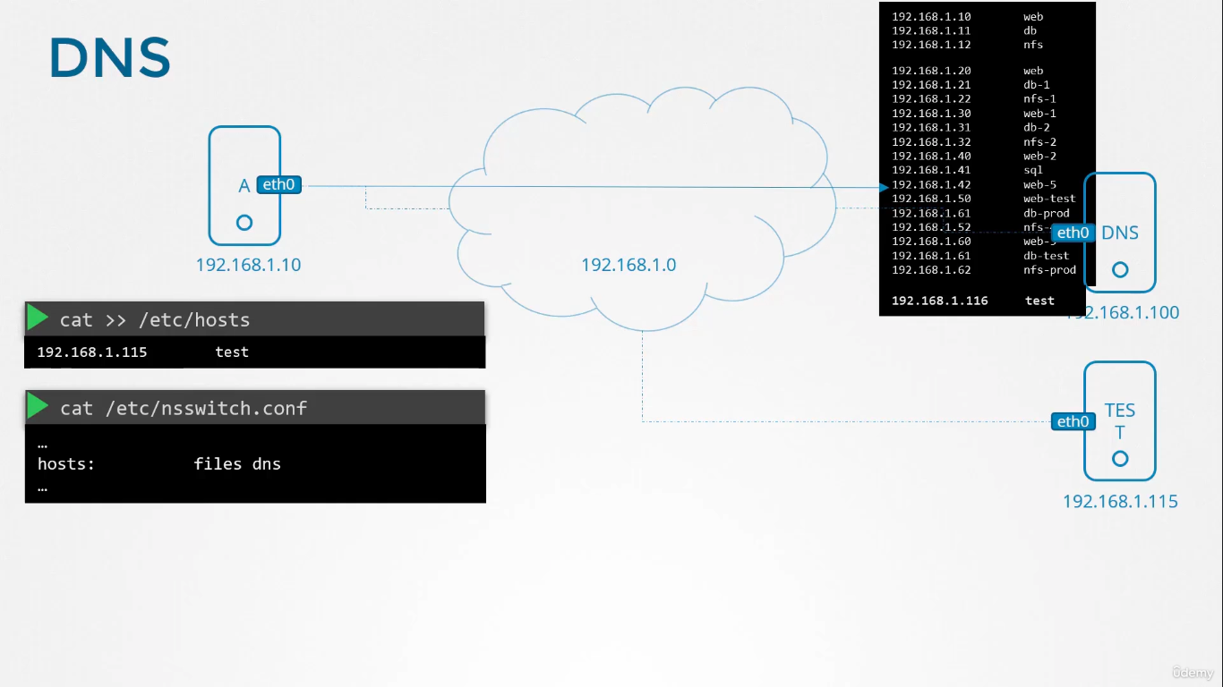

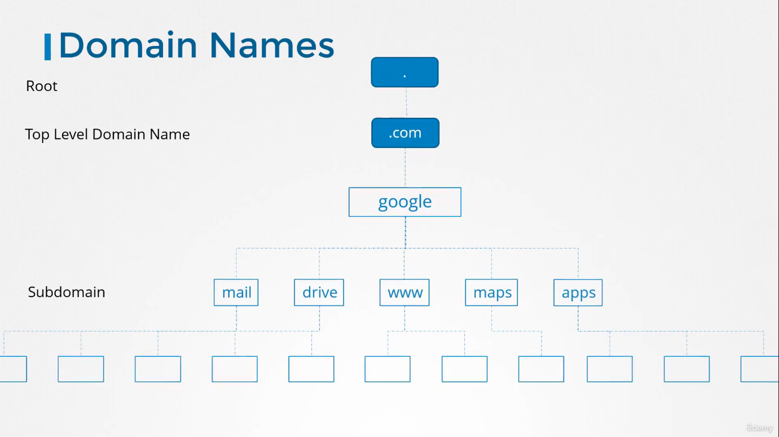

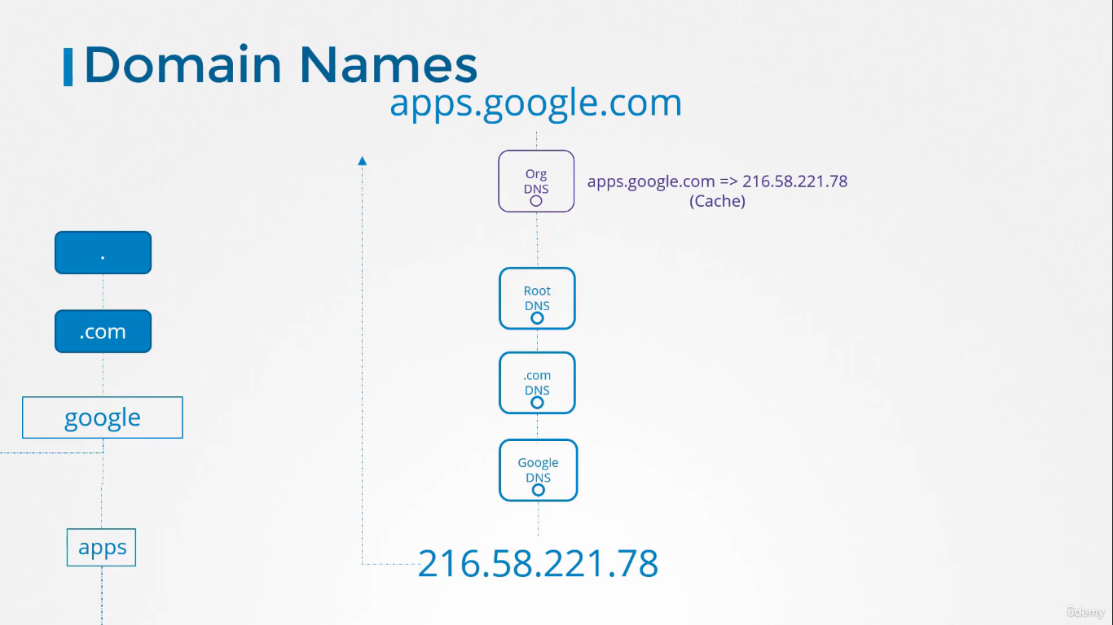

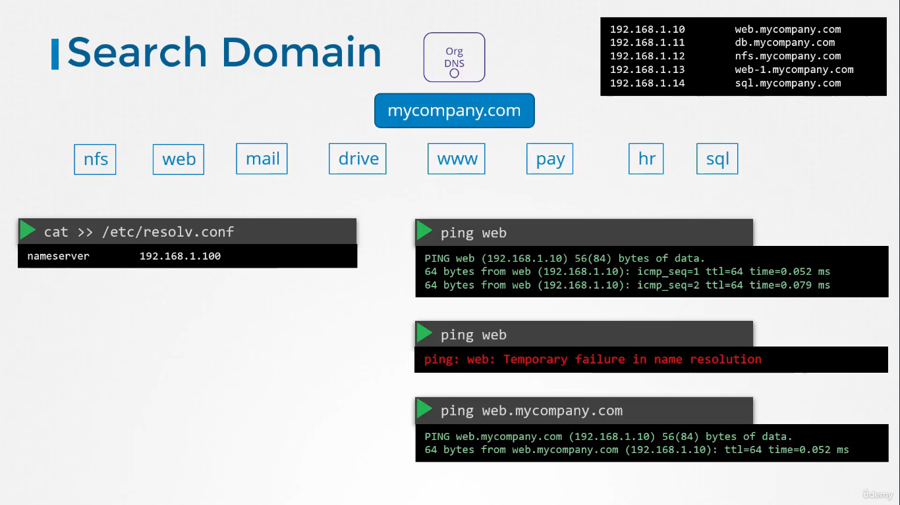

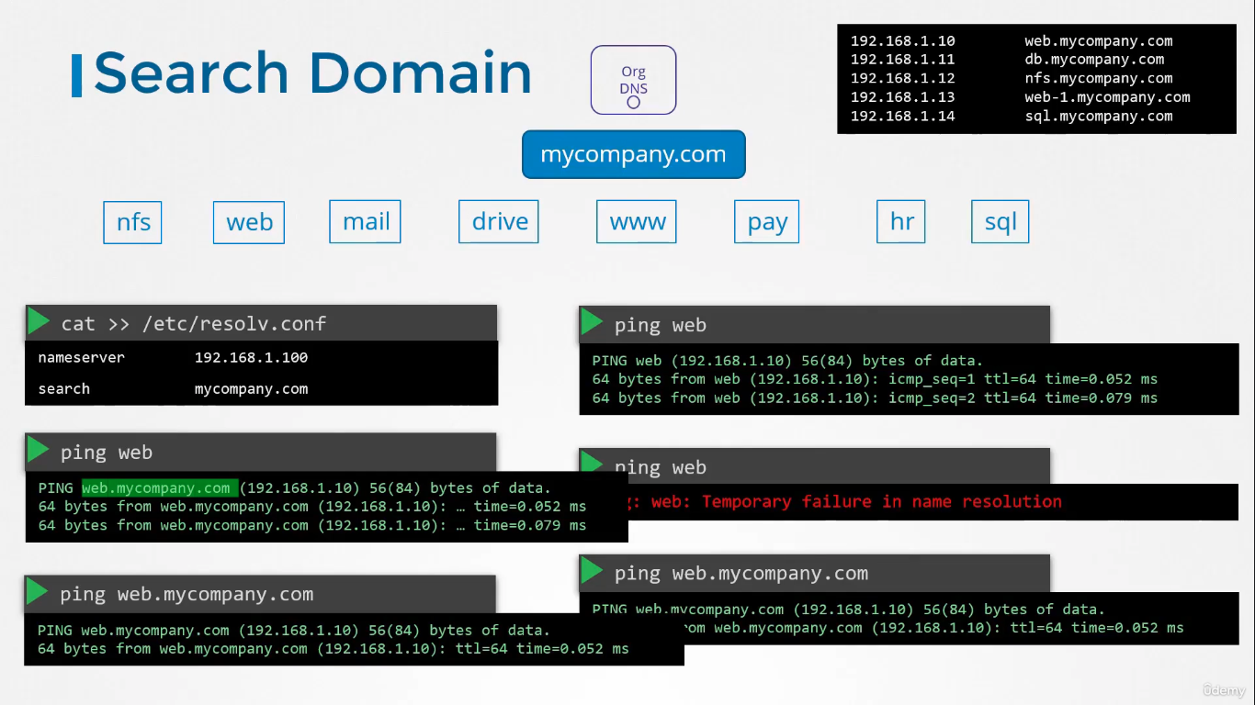
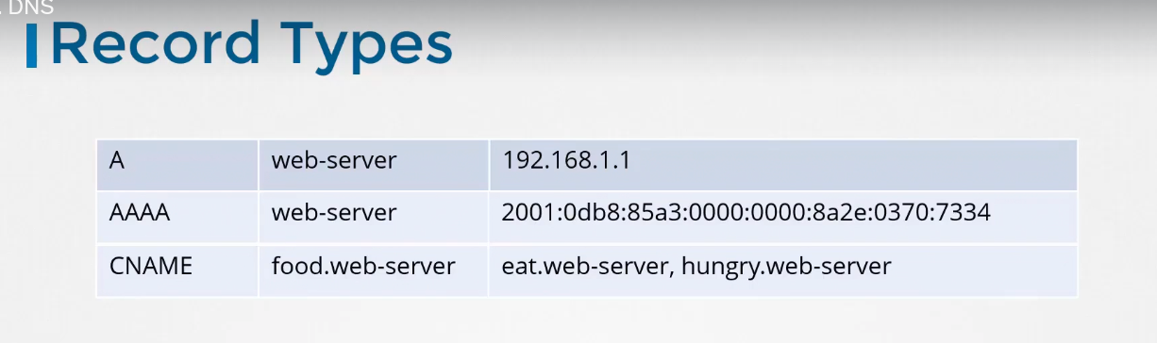

APPLICATION

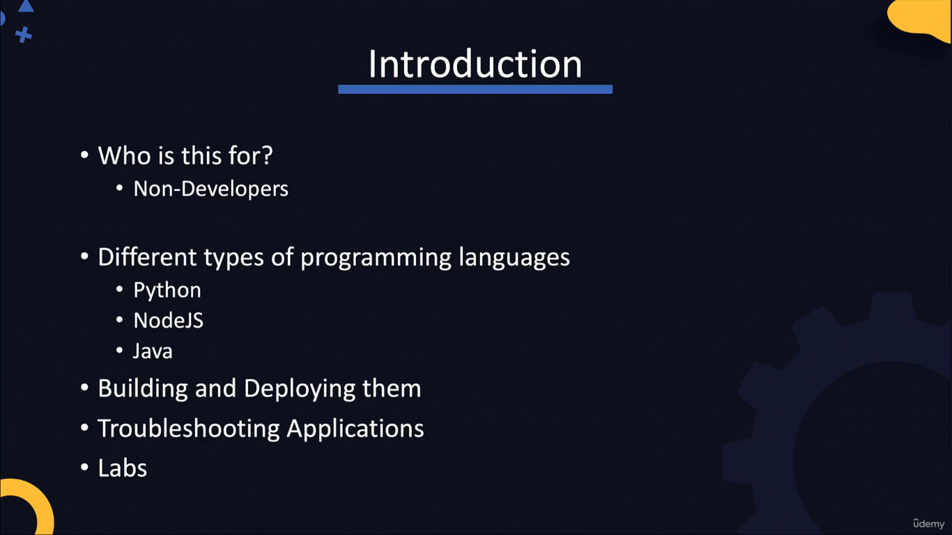
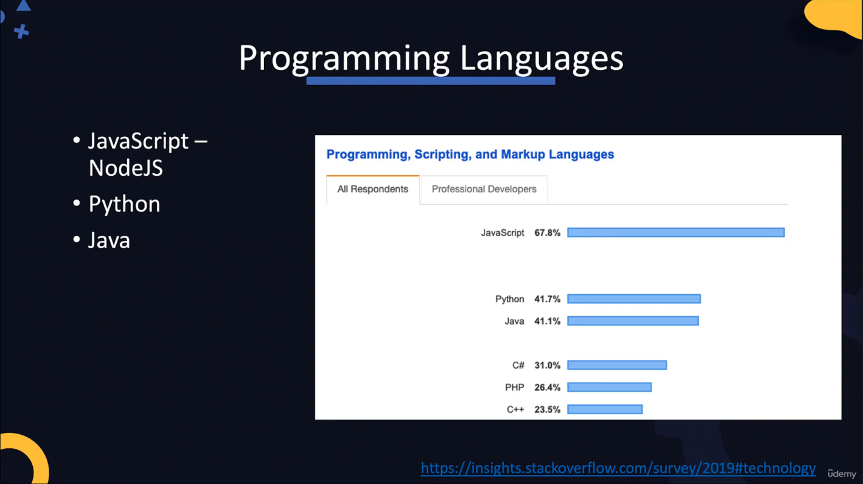

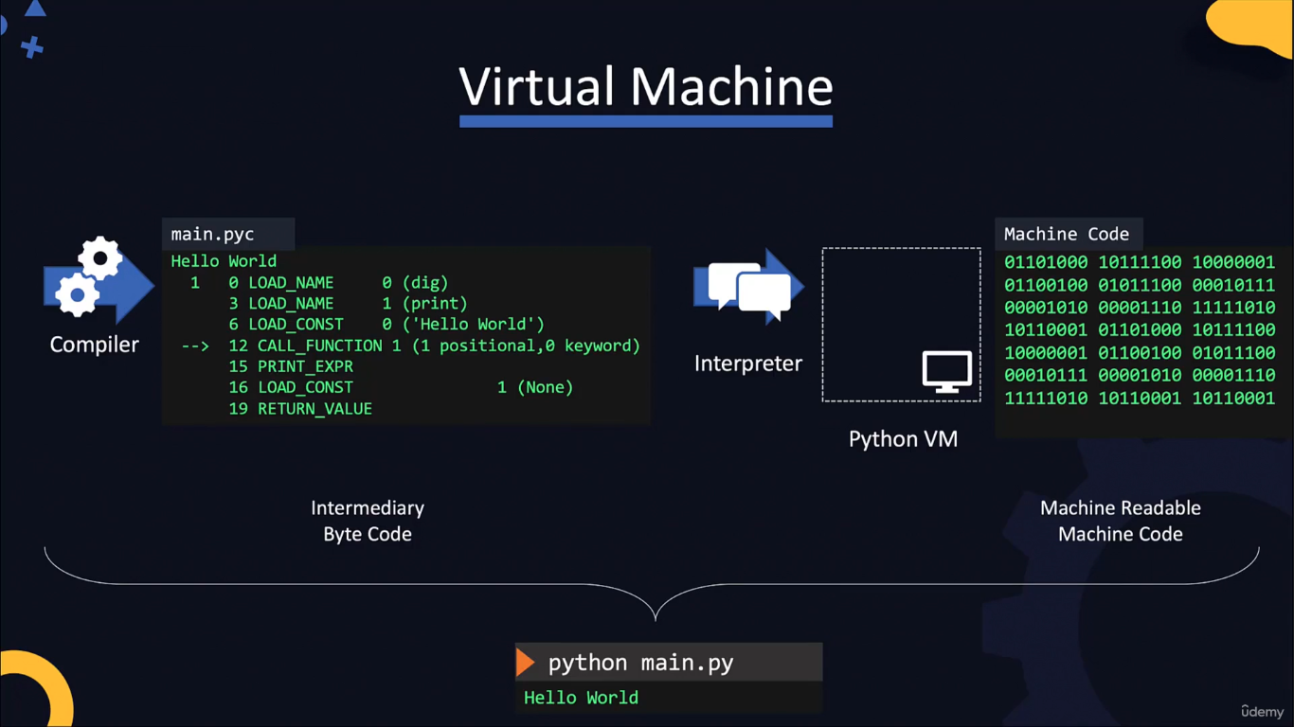

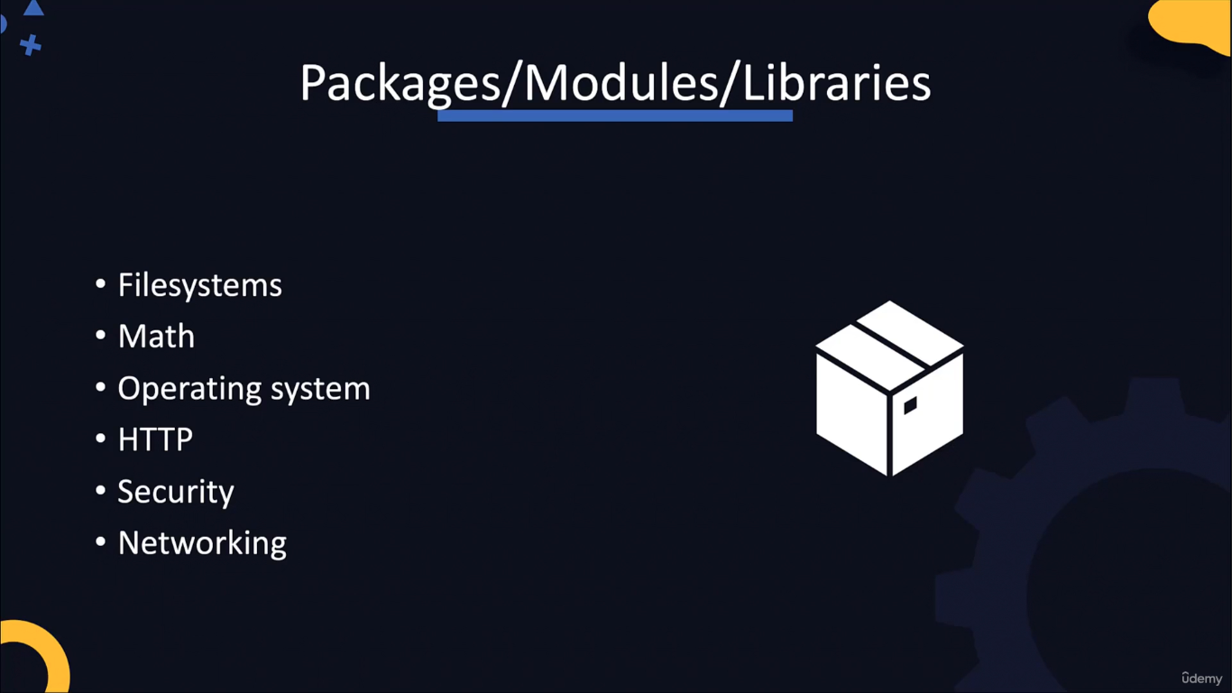

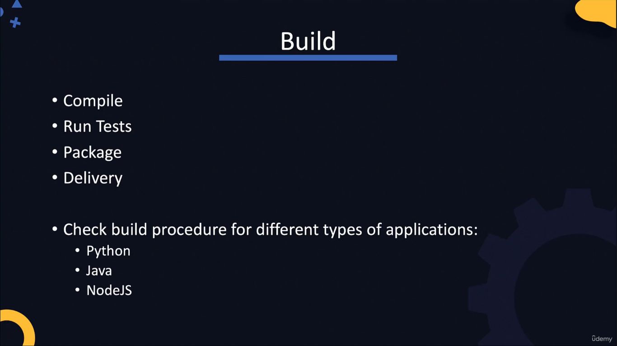

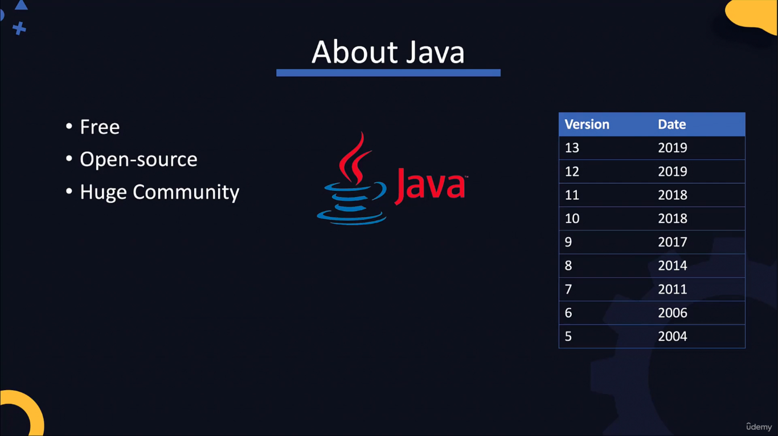

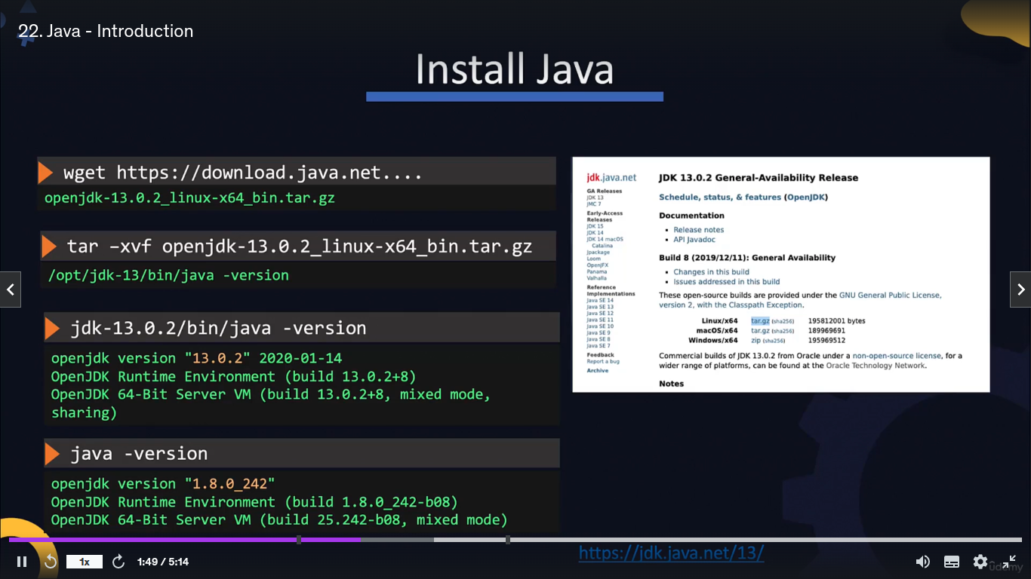
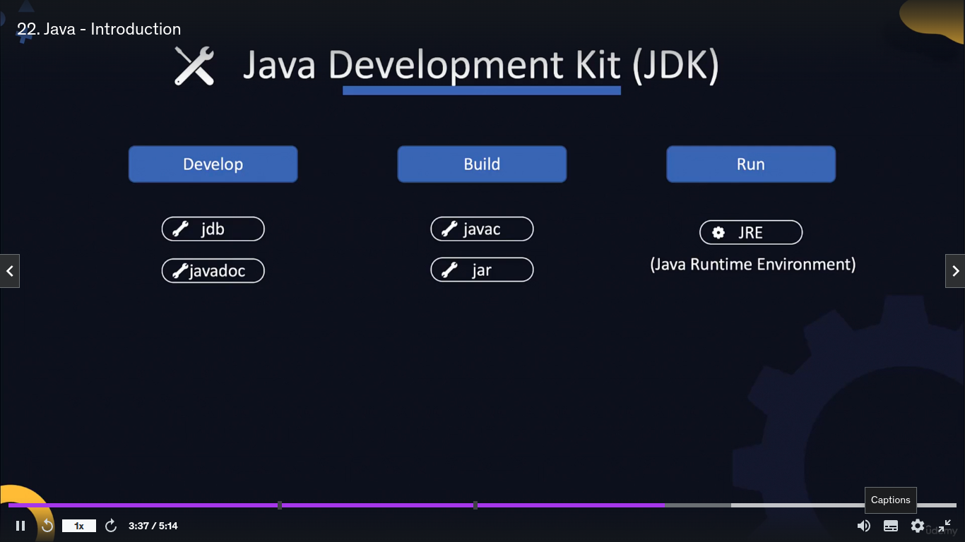

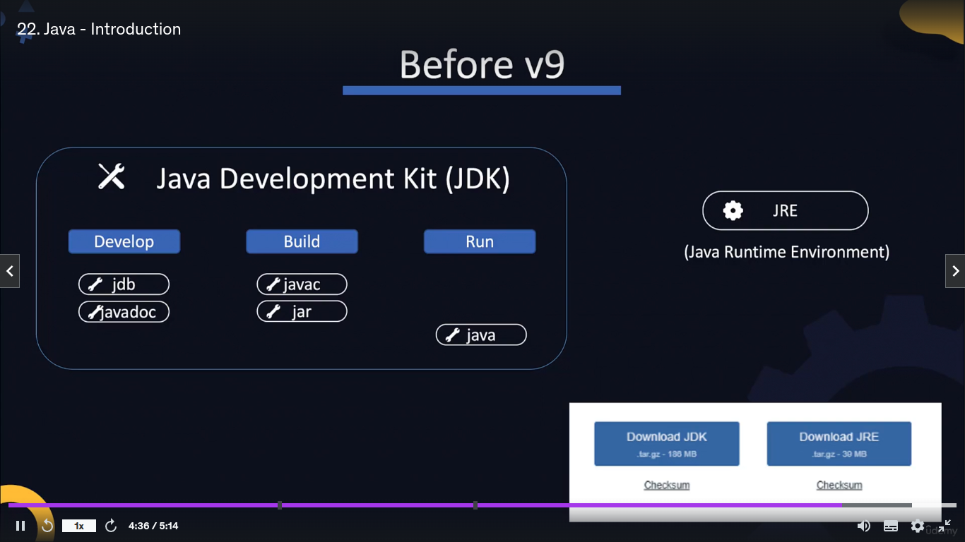

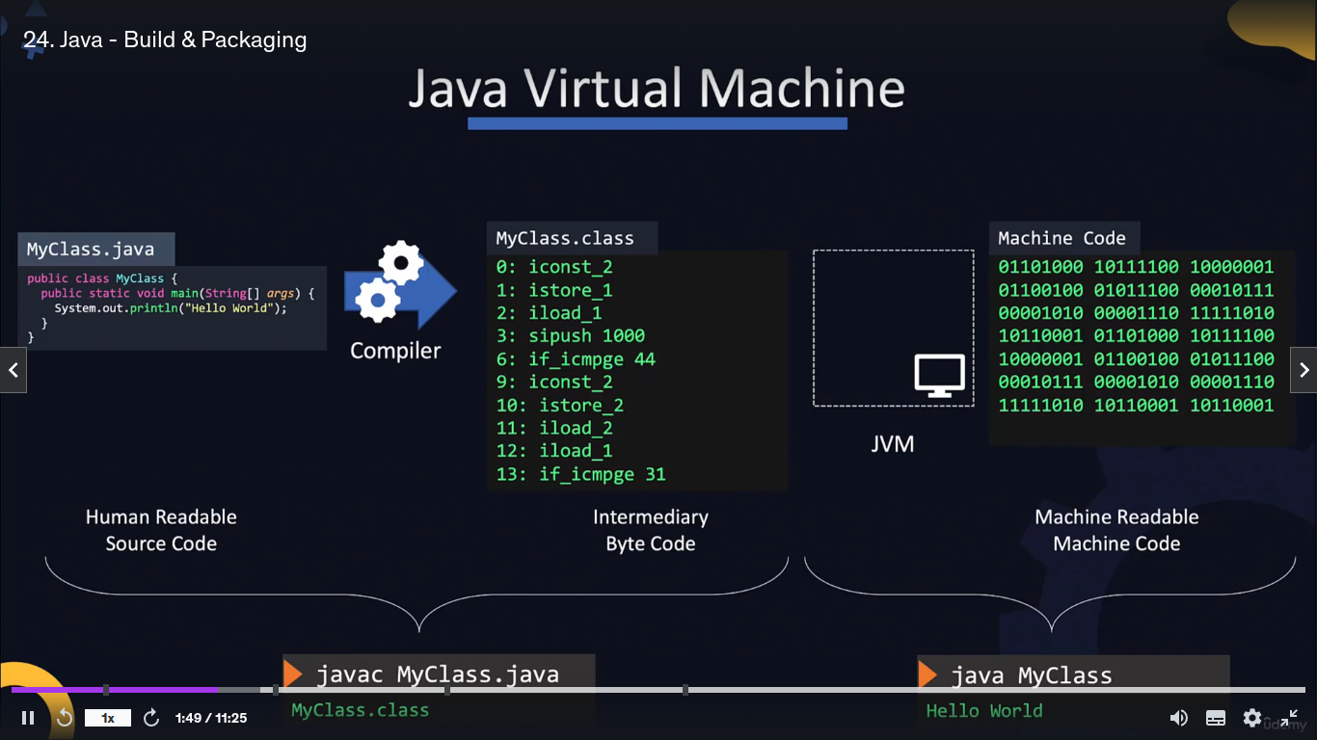
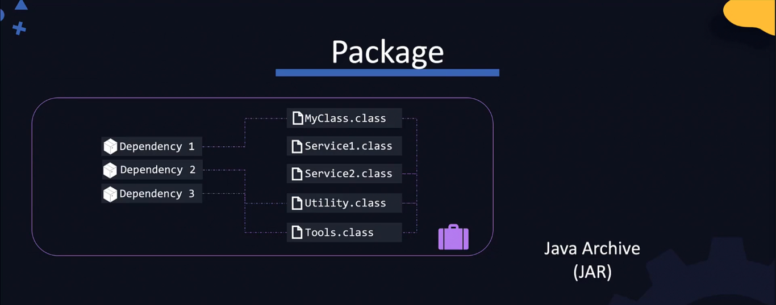
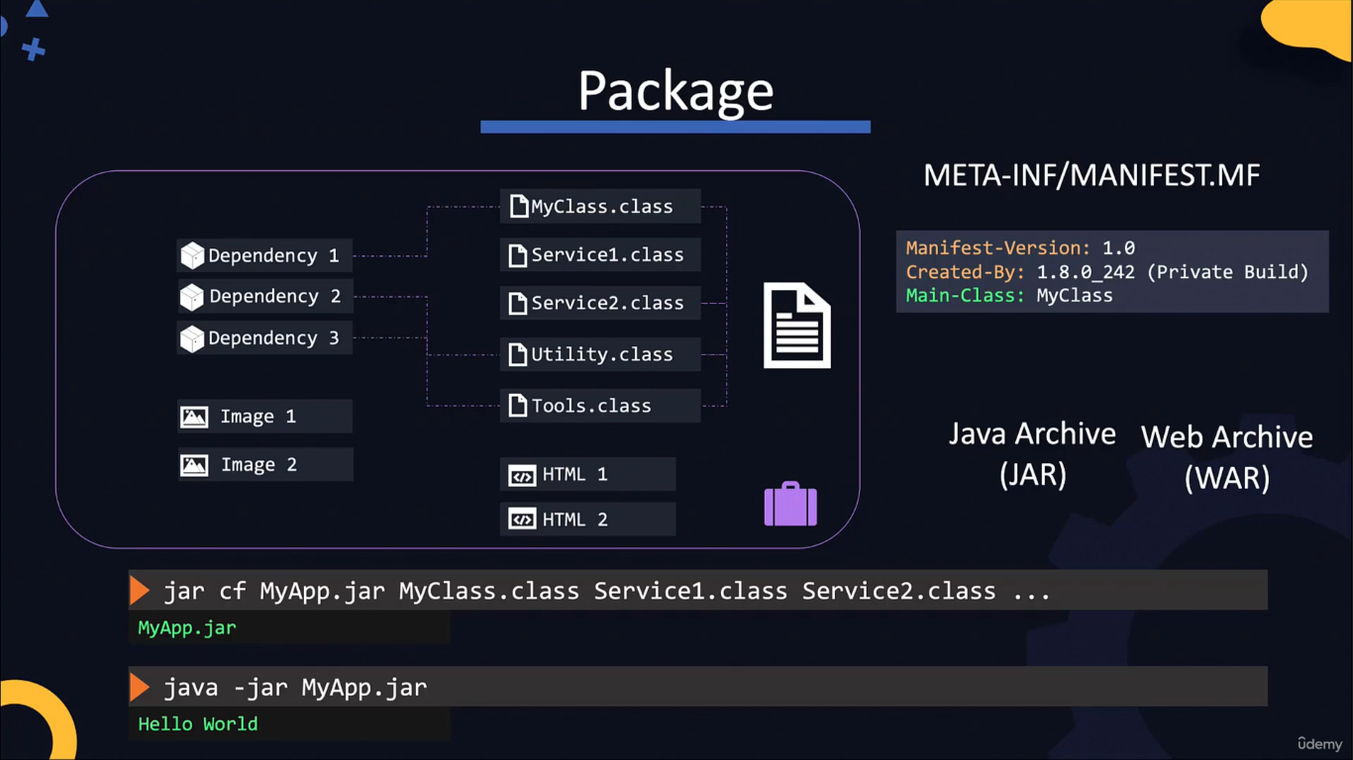
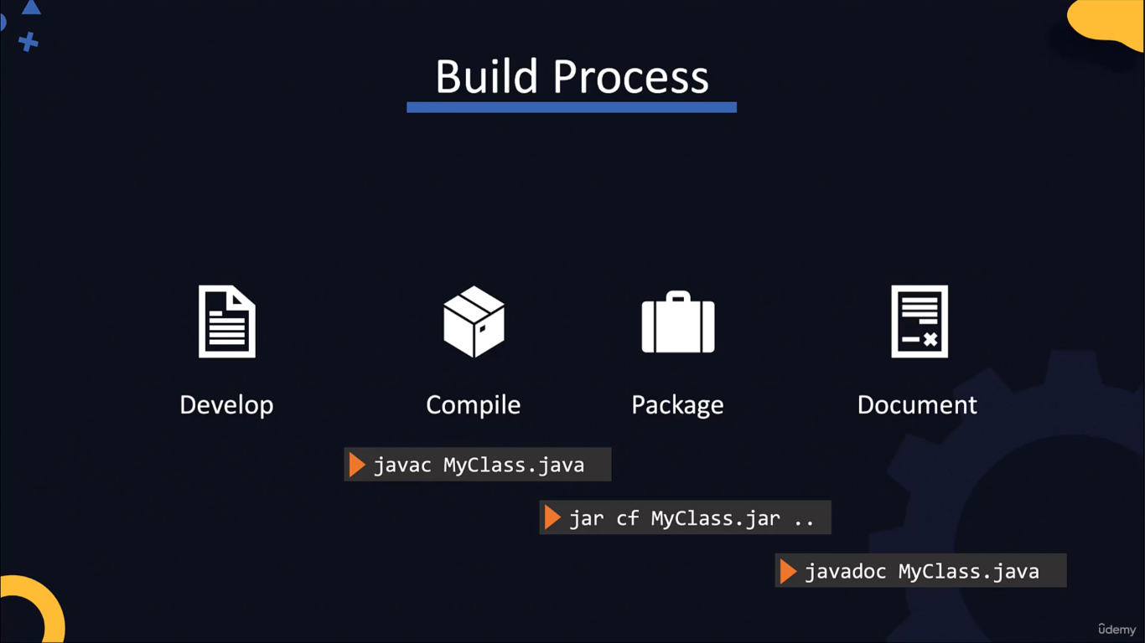
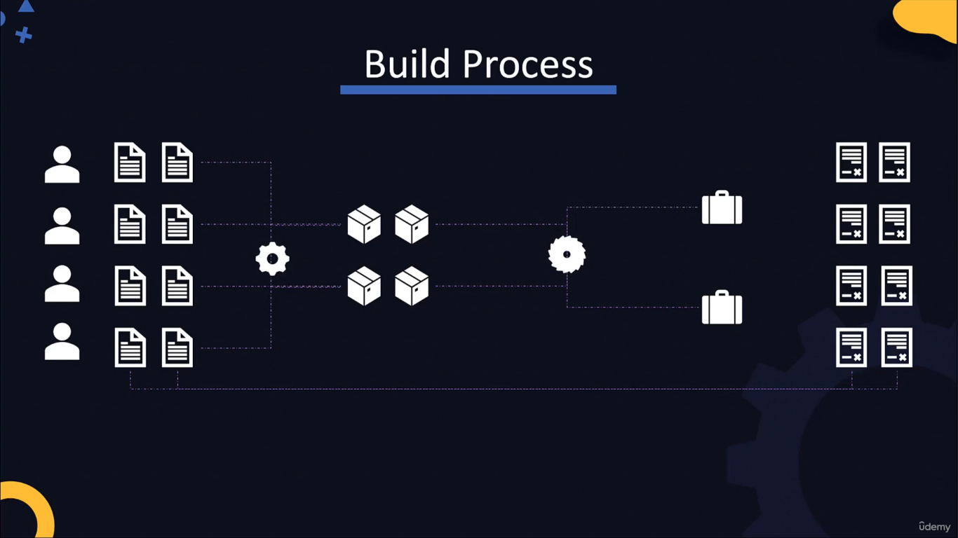
Buid tools are
Maven, Gradle, Ant


